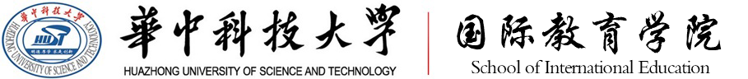

Huazhong University of Science and Technology (HUST), P. R. China is a top ranking university (#7 in China) in the world and a national key base for cultivating international students supported by the Ministry of Education, China. In 2018, over 3600 international students from 153 countries and regions studied at HUST. Until now, more than 300 students from 31 countries have finished their study at HUST with the support of Confucius Institute Scholarship.

2019 HUST Confucius Institute Scholarship application is going to close (May 20, 2019) and there are some seats for new applicants! We warmly welcome your students to study Chinese language at HUST as Confucius Institute Scholarship candidates.

For further info about the scholarship, please visit: http://iso.hust.edu.cn/Scholarships/Confucius_Institute_Scholarship_CIS_.htm

